Discrete Mathematics

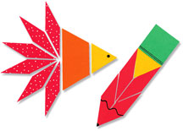

Kara Foehrenbacher

4th Grade-Northern Elementary

kara_foehrenbacher@bemidji.k12.mn.us

Christine Wade

4th Grade-Northern Elementary

christine_wade@bemidji.k12.mn.us

**Executive Summary**

In this unit, we will broaden students’ understanding of plane geometric figures including points, lines, line segments, rays, angles, and polygons. Students will also learn how to sort and classify angles and triangles. Students will also create numerical patterns and geometric patterns using pattern blocks and creating rules to go with their patterns and how they grow. This will transition students into creating and using input-output tables with a given rule.

**MN State Standards**

**4.2.1.1**: Create and use input-output rules involving addition, subtraction, multiplication and division to solve problems in various contexts. Record the inputs and outputs in a chart or table.

**4.3.1.1**: Describe, classify and sketch triangles, including equilateral, right, obtuse and acute triangles. Recognize triangles in various contexts.

**4.3.2.2**: Compare angles according to size. Classify angles as acute, right and obtuse.

**4.4.1.1**: Use tables, bar graphs, timelines and Venn diagrams to display data sets. The data may include fractions or decimals. Understand that spreadsheet tables and graphs can be used to display data.

**MCA Sample Questions**

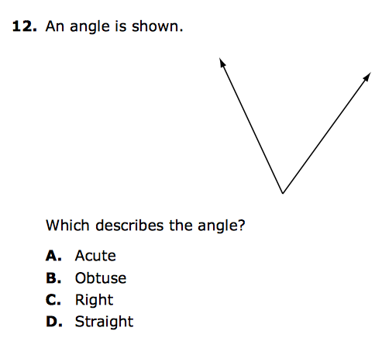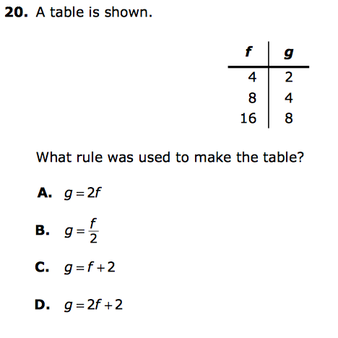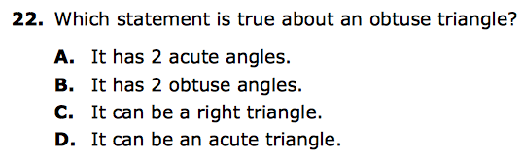

**TABLE OF CONTENTS:**

PRE-TEST 4-5

CLASSIFYING ANGLES 6-7

SORTING ANGLES 8-10

ALPHABET SORT & ANGLE COST PROBLEM 11-14

ANGLE SHAPE CHALLENGE & ADDING ANGLES 15-16

NAME & IDENTIFY TRIANGLES 17-18

NAME TRIANGLES BY THEIR SIDES 19-20

SORT & CLASSIFY TRIANGLES 21-23

GEOMETRIC PATTERNS- REPEATING 24-25

GEOMETRIC PATTERNS- GROWING 26-27

GROWING & REPEATING PATTERN TASK CARDS 28-31

NUMERICAL PATTERNS 32-33

NUMERICAL PATTERNS WITH TABLES 34-36

PATTERN RULE GAME 37-39

FUNCTION TABLES 40-42

POST-TEST 43-44

**PRE-TEST**

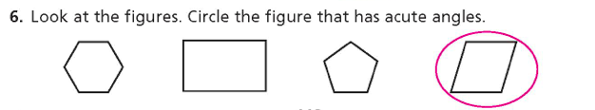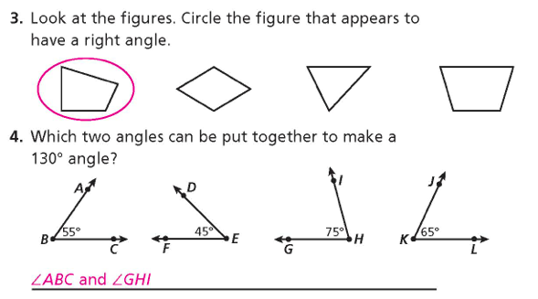

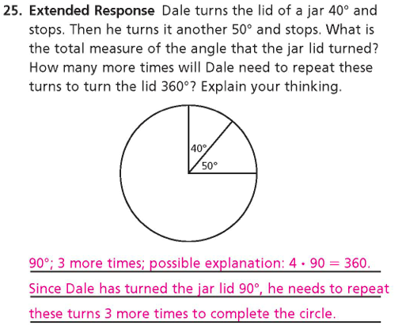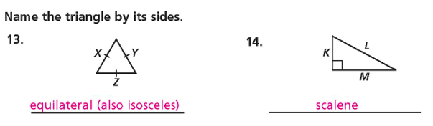

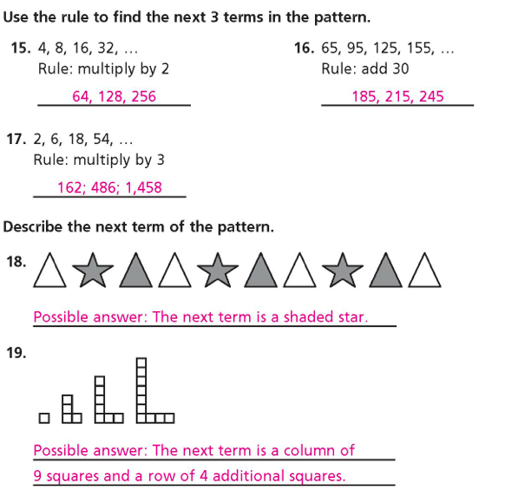

**Day 1- classifying Angles**

**Launch**

Using prior knowledge of how to draw and label angles, we will be creating and classifying three different angles using pencils, straws, and pipe cleaners. Using these materials, students will create as many angles as we can and come up with definitions for each one. We will be addressing standard 4.3.2.2: Compare angles according to size and classifying angles as acute, right and obtuse.

Explore

Whole Group

Students will recognize that a right angle looks like the corner of a rectangle or square. Using two pencils, and the corner of a piece of paper, students will create a right angle, also known as a 90 degree angle. How can you remember what a right angle is?

Small Group

Working in groups of 4, students will be given two straws and a pipe cleaner. They will insert the pipe cleaner into an end in each of the straws to create an angle. Students in each group will first recreate a right angle. This is an angle with 90 degrees and looks like the corner of a rectangle or square. Using their straws, they will see how many different ways they can flip or reverse their angles without changing the angle size. Students will come up with a definition and drawing in their notebook for a right angle.

Next, students will create as many angles as they can that are smaller than a right angle, also known as an acute angle. Students will share with their group the angle they came up with. Working together, students will come up with a definition for an acute angle and include a drawing to go with it.

Lastly, students in each group will create as many different angles as they can that are larger than a right angle, also known as an obtuse angle. Students will share with their group the angles they came up with and together create a definition and include a drawing to go with it.

Working together, each group will complete class activity 8-1 (p. 275).

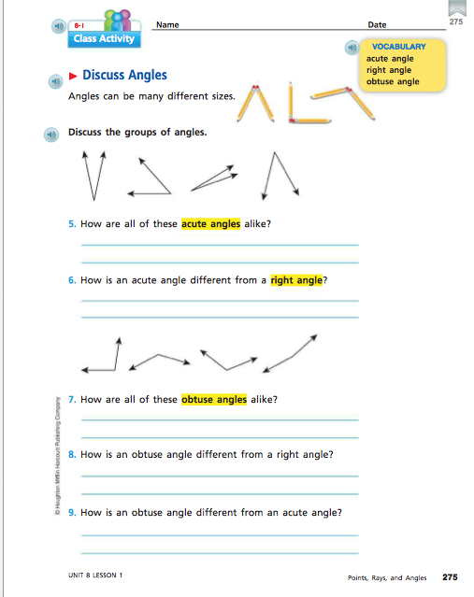

Share

Students will share their group’s definition and drawing for each of the three angles covered into today’s lesson. What is different about these angles? What do these angles have in common? Are there many ways to represent acute and obtuse angles? We will then go over class activity 8-1 (p. 275) and have each group share their answer.

Summarize

The main idea of this lesson was to discuss, create, and define right, acute, and obtuse angles. Students should also know that a right angle is 90 degrees. By sharing the definitions students created, students will see there are rules in order to classify an angle. By sharing their drawings, students will see that, with acute and obtuse angles, there are many ways to represent them.

Fuson, Karen C. *Math Expressions. Common Core*. Orlando, FL: Houghton Mifflin Harcourt, 2013. Print.

Day 2: Sorting Angles

**Launch**

In today’s lesson, we will review the three angles students classified yesterday along. On the board will be a drawing of a right angle with a square in the corner to remind students what a right angle looks like. Also on the board will be a drawing to show how four right angles can be arranged to form a circle. Students will be given a sheet of 16 different angle cards to cut out. Students will then compare each angle to a right angle and sort the angles into three different groups. Students will also compare each angle to a straight line, also known as 180 degrees, and sort each card into three different categories. We will be addressing standard 4.3.2.2: Compare angles according to size and classifying angles as acute, right and obtuse.

Explore

.In a small group of 4, using class activity 8-1 (p. 276A) students will cute out each of the 16 sort angle cards.

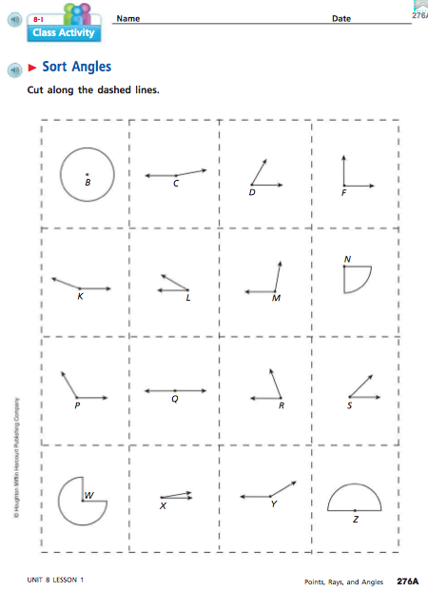

In each group, students will sort the cards into the three categories: angles that appear to be smaller than a right angle, angles that appear to be a right angle, and angles to appear to be larger than a right angle. In their groups, students will discuss why they placed each card in the chosen column. Students will record answers on a three-column spreadsheet.

|  |  |  |
| --- | --- | --- |
| Smaller | About the Same | Larger |
|  |  |  |

Students will also sort their angle cards into three categories: angles that appear smaller than a straight angle, angles that appear to be a straight line, and angles that appear to be larger than a straight line. In their groups, students will discuss why they placed each card in the chosen column. Students will record answers on a three-column spreadsheet.

|  |  |  |
| --- | --- | --- |
| Smaller | About the Same | Larger |
|  |  |  |

Using Activity Card 8-1, students will look at angles formed in many of the letters in the alphabet. Students should draw upper case (capital) letters large enough to be able to recognize the angle types.

Share

Students will share their results from the first sort, comparing angles to a right angle, with the class and explain their reasoning. How did you know which angles went where? Were there any angles you had questions about? All angles sorted will be recorded from each group. Students will also share the results from their second sort comparing angles to straight line. Was this sort easier than the first sort? Why or why not? What was similar between the two sorts? Were there any angles that you were confused about for either sort? What was confusing about these angles?

Summarize

The main idea of this lesson was to review right, acute, and obtuse angles as well as understand that there is such a thing as straight angles and they are 180 degrees. Students got practice with sorting angles into different categories and how to compare them to one another.

Fuson, Karen C. *Math Expressions. Common Core*. Orlando, FL: Houghton Mifflin Harcourt, 2013. Print.

Day 3- Alphabet Angles & Angle Cost Problem

Launch-

Today, students will be using capital letters of the alphabet, with straight segments, to find all of the angles formed in each letter. Students will also be working on an angle cost problem. Tell students to imagine they are going to work on a project and need to have some shapes cut from blocks of wood. However, the carpenter who will be cutting the shapes has a strange way of charging for his service. He charges by the number and type of angle needed to create each shape. We will be addressing standard 4.3.2.2: Compare angles according to size and classifying angles as acute, right and obtuse.

Explore

For the first activity, students will work with a partner. Students will complete activity card 8-1 called Alphabet Angles. Students will record their capital letters along with the labeling of each angle found in each letter in their notebooks.

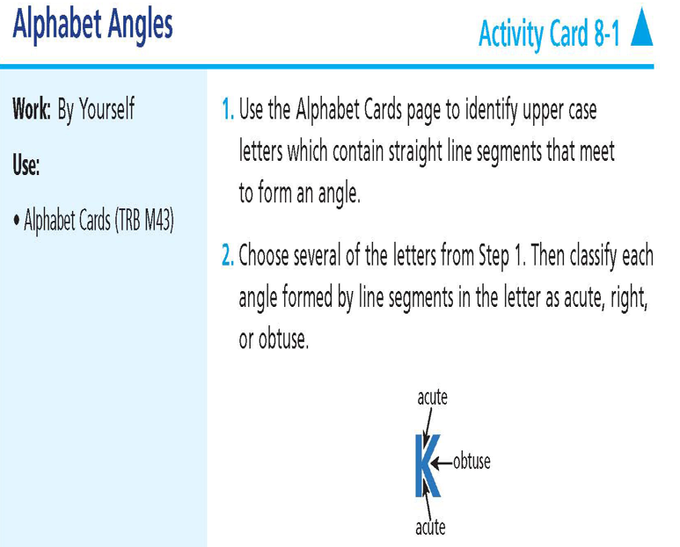

For the second activity, students will be in a group of four. Display the Angle Cutting Costs (pg. 8) illustrations and prices on the board.



Show the Angles in Shapes Practice (pg. 9) and have the students try to figure out how much the carpenter would charge to cut each shape. Demonstrate how to identify each angle and mark it with the price, then add to find the total cost (Shape #1= 60**¢** Shape #2= 75**¢)**



Then give each team the Angles in Shapes Team Page (pg. 10) and have them cut apart the shapes and pass them out according to number.



Each person should figure out the cost of his or her own shape, then trade with a partner to check each other’s calculations. Record of this will be kept in their notebook.

Share

As a class, first discuss the capital letters used for the alphabet angles activity. Which letters could you not use? Why? Are there any letters that use only acute angles? Are there any letters that use only right angles? Are there any letters that use only obtuse angles? Did you find a letter with only 1 angle? 2 angles? 3 or more angles?

* For the angle cost problem, what was the cost of each shape? What calculations did you use to figure this out? Are there any patterns that you noticed? Which shape is the most expensive? (#4) Which on is the lease expensive? (#3)

Summarize

The main idea of this lesson was to have students classifying angles, but only when the lines forming that angle were straight. Students also were given practice with identifying angles in given shapes and adding up those angles.

Candler, L., (2015). Angles in Shapes. Retrieved June 27, 2016 from: [www.lauracandler.com](http://www.lauracandler.com)

Fuson, Karen C. *Math Expressions. Common Core*. Orlando, FL: Houghton Mifflin Harcourt, 2013. Print.

* Day 4- Angle Shape Challenge & Adding Angles

Launch

Using the knowledge students gained from yesterday’s angle cost problem, students will do an angle shape challenge. With this challenge, what is the most expensive shape you can make using 5 straight lines?

The second activity of this day has students sharing when they use operations with measurement units. A common reference is adding lengths of sides to find perimeter. Students will also recognize that the measure of an angle is the sum of the measure of its parts. They will have practice with adding angle measures using class activity 8-5 (p. 289) and creating their own addition angle problems.

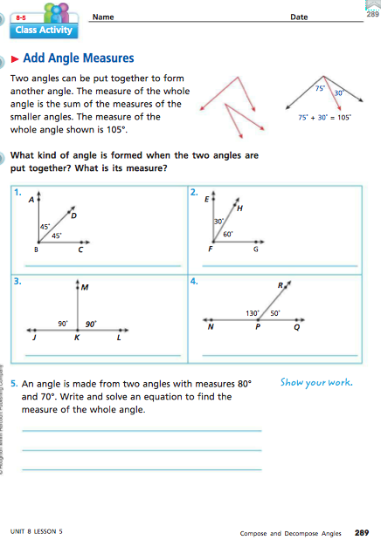

Explore

Students will begin individually working on the angle shape challenge. With five lines of any length, they will try to create the most expensive shape. The price of each angle is the same from yesterday’s lesson. When they have created an expensive shape, they will compare their answer with a partner.

For the second activity, students will work on class activity 8-5 (p. 289) in pairs. After completing the class activity, pairs will create four angle addition problems, one for a right angle, an obtuse angle, an acute angle, and a straight angle. Students will exchange their four angle addition problems with another group to complete.

Share

For the angle shape challenge, have students who created the most expensive shape share with the class. What strategy did they use to create their shape? Have students share various strategies used. Are there different shapes that cost the same amount?

For the adding angles activity, have students share their four angle addition shape problems with the class. Record the angles used to create a right, obtuse, acute, and straight angle. How many ways are there to create an acute angle? Obtuse angle? Right angle? Straight angle? Can you create and acute angle using only acute angles? Can you create an obtuse angle using only acute angles?

Summarize

The main idea of this lesson was to get students to create different shapes using a specific number of lines and classifying each angle in the shape. Students are also able to add two angles together and determine what angle the combination of the two angles make. Students were also able to see that there are many different ways to create acute, right, obtuse, and straight angles.

Candler, L., (2015). Angles in Shapes. Retrieved June 27, 2016 from: [www.lauracandler.com](http://www.lauracandler.com)

Fuson, Karen C. *Math Expressions. Common Core*. Orlando, FL: Houghton Mifflin Harcourt, 2013. Print.

Day 5- Naming & Identifying Triangles

Launch

Today we will be focusing on the prefix tri-. The prefix tri-, like tricycle, triple, triplets, means three. A TRI-angle is a three-sided figure that we will work with. In today’s lesson, students will be making triangles and naming them by their angles. Using a specific number of toothpicks for each side, students will create different triangles and classify them based on their angles. The state standard addressed is 4.3.1.1: Describe, classify and sketch triangles, including equilateral, right, obtuse and acute triangles. Recognize triangles in various contexts.

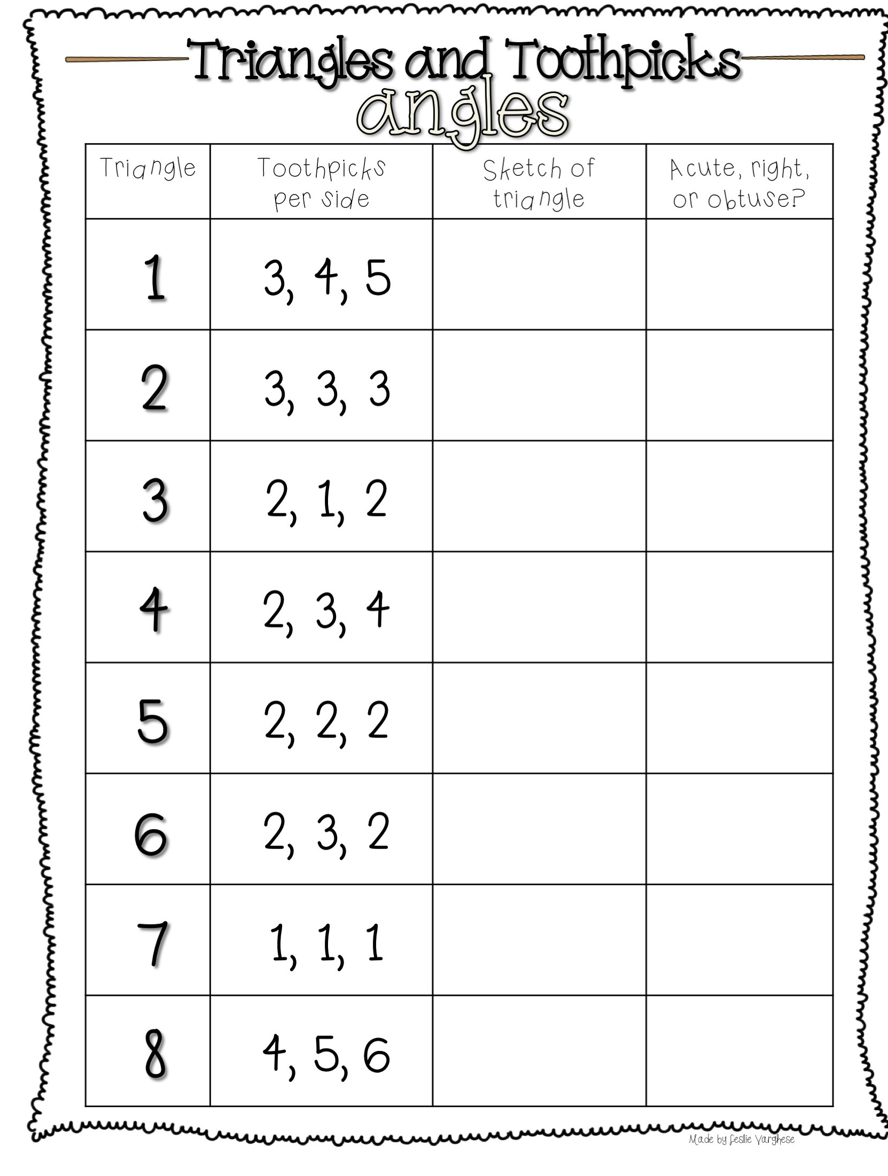

Explore

Whole Group

Have students draw a right, acute, and obtuse angle in their notebook. Have students draw a third side for each angle to close in the shape. The shape they have created is a triangle. Have students label each triangle based on its original angle drawn.

Small Group

Have students work in groups of four to come up with differences between each of the three triangles created. Responses should be:

Right triangle: one right angle, two other angles (both acute)

Acute triangle: all three angles are acute

Obtuse triangle: on obtuse angle and two other angles (both acute)

Using their differences found, have each group complete the toothpicks and triangles worksheet together. They must compose a triangle based on the specifications listed, sketch the triangle created, and classify it as an acute, obtuse, or right triangle.

Share

Students will share how they created a triangle using a drawn angle. How did you do this? Can you create a triangle without drawing an angle first? If so, how can you determine what type of triangle it is?

Students will also share the differences they came up with in their small group for each triangle. How can you tell them apart from one another? Do they have anything in common?

With the triangles and toothpicks activity, could you determine what type of triangle it would be before constructing it with the toothpicks? If so, how?

Summarize

Today’s lesson was about naming, describing, and composing right, acute, and obtuse triangles. Students were able to come up with ways to tell each triangle apart from one another and were also able to come up with reasons why a given triangle was identified as right, acute, or obtuse.

Varghese, L. (n.d.) Triangles and Toothpicks. Retrieved June 28, 2016 from: [www.teacherspayteachers.com](http://www.teacherspayteachers.com)

Day 6- Naming Triangles by Their Sides

Launch

Yesterday, students were able to identify triangles by their angles. But, what if you don’t have a protractor or the angles are not measured? Today, we will explore how to identify triangles by the length of their sides using toothpicks. The state standard addressed is 4.3.1.1: Describe, classify and sketch triangles, including equilateral, right, obtuse and acute triangles. Recognize triangles in various contexts.

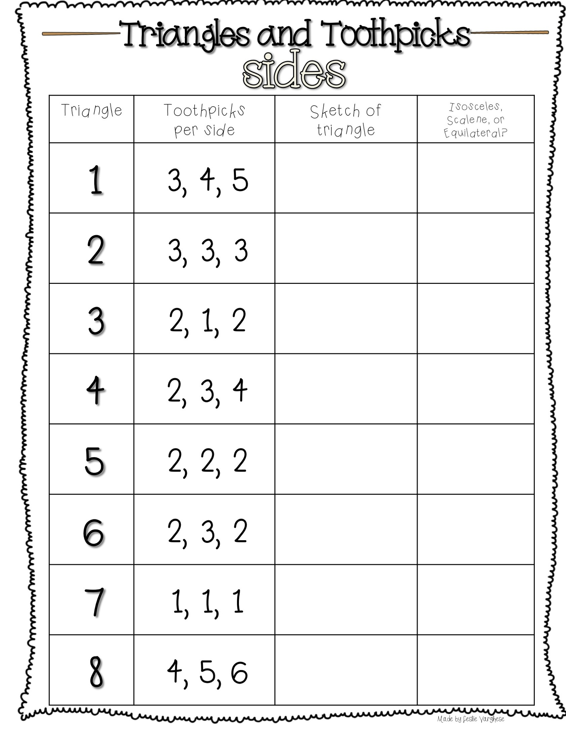

Explore

Whole Group

Direct students to the board where displayed are three different triangles named by their sides: equilateral, isosceles, and scalene. Discuss as a class how you can decide if a triangle is equilateral, isosceles, or scalene. By comparing the lengths of its sides, you can determine what type of triangle it is. Equilateral triangles all have the same length sides (equal). Isosceles triangles have two sides that are equal in length. Scalene triangles have no equal sides. Have students record this into their notebooks before the toothpicks and triangles activity.

Small Group

Using toothpicks and the triangles and toothpicks recording sheet, students will construct a triangle given the specifications given. Once the triangle is constructed, groups will sketch their triangle and classify it based on the length of its sides: equilateral, isosceles, or scalene. Students can count the number of toothpicks used on each side to help them determine what type of triangle it is.

Share

Using your results from the triangles and toothpicks activity, is there a pattern you recognized? Could you determine what type of triangle it was going to be without constructing or drawing it out first? How? How is this different from yesterday’s toothpicks and triangles activity?

Summarize

The main idea of this lesson was to get students to identify and classify triangles based on the length of their sides.

Varghese, L. (n.d.) Triangles and Toothpicks. Retrieved June 28, 2016 from: [www.teacherspayteachers.com](http://www.teacherspayteachers.com)

Day 7- Sorting & Classifying Triangles

Launch

Using the toothpicks and triangles activity done the past two days, students will sort various triangles based on their angles and sides. Using a Venn diagram, each group of students will create their own triangle sort for other groups to determine the rule used to sort their triangles. Class activity 8-4 (p. 287) will have the Venn diagram and triangles used. The state standard addressed is 4.3.1.1: Describe, classify and sketch triangles, including equilateral, right, obtuse and acute triangles. Recognize triangles in various contexts. The state standard addressed in this lesson is 4.4.1.1: Use tables, bar graphs, timelines and Venn diagrams to display data sets. The data may include fractions or decimals. Understand that spreadsheet tables and graphs can be used to display data.

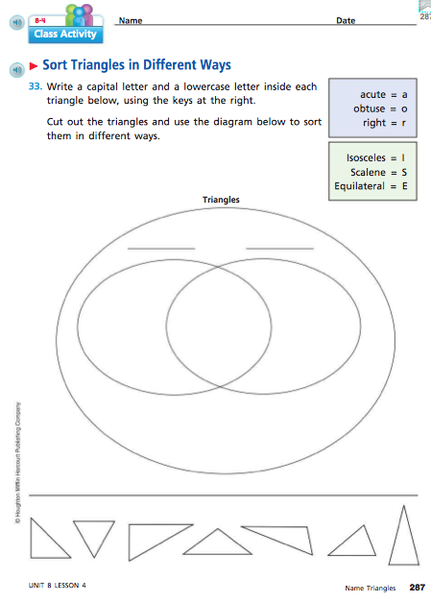

(Cheat Sheet)

Macintosh HD:Users:karafoehrenbacher:Desktop:ClassifyingTrianglesGraphicOrganizer copy.pdf

Explore

Whole Group

To start off this lesson, I will have different pattern blocks up on the visualizer for all students to see. I will use the triangle, circle, and square pattern blocks in the red, yellow, and green colors. As a class, we will list different attributes for each pattern block. For example, all triangles have three sides, have acute angles, are equilateral, and are found in the colors green, yellow, and red. Then, we will determine a way to sort these pattern blocks into our Venn diagram. Example sorts would be blocks that are yellow and squares. All yellow blocks will go on one side of the Venn diagram, all squares will go on the other side of the Venn diagram, and all yellow squares will be placed in the middle. If there are any blocks that do not fit this rule, they will be placed on the outside of the Venn diagram to show that they did not fit the rule. Another great resource is the website: <http://www.shodor.org/interactivate/activities/ShapeSorter/>

Here, you can have students come up to the board and physically move the shapes into the Venn diagram. This website allows you to use one circle, two separate circles, or two circles overlapping. It allows you to choose a rule for each circle and when sorting, it will also correct any errors that may occur. If students are trying to move a shape into a part of the diagram and it’s not working, this is a great discussion starter as to why it won’t work.

Small Group

In groups of 4, students will first classify each triangle at the bottom of class activity 8-4 (p. 287). They will need to classify each triangle by their sides and angles using the key given. Once all triangles are classified, students will cut them out and as a group, determine how to sort them using a Venn diagram. Examples of ways to sort are acute & isosceles, right & scalene, or obtuse & scalene. Students could use the classifying angles cheat sheet if needed for this activity as some combinations are not possible to create. When the Venn diagrams are done, student groups will visit each other’s Venn diagram to see if they can determine how that group sorted their triangles.

Share

What did you notice about classifying each triangle? Are there any triangles that you could not classify with a specific side and angle? If so, why is that? Have groups share their triangle sort with the class and have each group determine how each group sort their triangles. If you had any triangles outside of the Venn diagram, why is that?

Summarize

In this lesson, students were able to describe ways to name triangles using sides, angles, or both. Students were also able to find numerous was to sort triangles based on their identity.

Fuson, Karen C. *Math Expressions. Common Core*. Orlando, FL: Houghton Mifflin Harcourt, 2013. Print.

Parker, M. (2014). Classifying Triangles Graphic Organizer. Retrieved June 29, 2016 from: [www.teacherspayteachers.com](http://www.teacherspayteachers.com)

Day 8- Geometric Patterns-Repeating

Launch

Using the pattern blocks from yesterday during our Venn diagram shape sort, students will be creating, identifying, and extending repeating patterns. They will be able to identify a given term based on the patterns created. To complete this activity, students will need a handful of pattern blocks, and class activity 4-11 (p. 156).

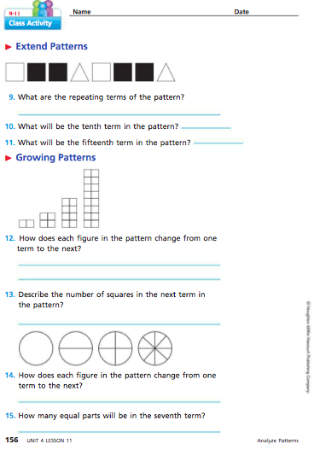

Explore

Whole Class

Display a pattern of square, triangle, circle, square, triangle, circle, etc.… on the bar for students to view. Talk about how to describe this sequence (made up of squares, triangles, and circles). In this pattern, the first shape, is known as a term. The first term in this pattern is a square. The second term is a triangle. Ask students how many terms there are in this pattern (6). Explain to students that this pattern is called a repeating pattern because some of the terms repeat. The first three terms are square, triangle, and circle. What will the next three terms be? What will the 10th term be? How do you know?

Small Group

In each small group, each student will have a handful of pattern blocks. Have students arrange their pattern blocks into any repeating pattern that they’d like. Have students keep their repeating pattern shorter than 10 terms. Once all patterns are complete, have students in each group explain their repeating pattern to each of their group members.

Next, have students see if they can figure out what the 12th term in each pattern will be. To check their work, have them extend their pattern out to the 12th term to see if they are correct. Once everyone is done, have them figure out what the 15th and 20th term will be using the same method as above.

When students have all extended their patterns out, they will work on questions 9-11 on class activity 4-11 (p. 156) as a group.

Share

Have 1 student from each group share their repeating pattern created with the class. Make sure you have different patterns. What was the largest pattern found? What is the smallest pattern found? Can each group figure out the next term? Are you able to do that without using a pattern block? Can each group determine the 15th term? How about the 25th term? Is there a way to determine what block it will be without using your blocks?

Summarize

The main idea of this lesson is to get students familiar with identifying and creating repeating patterns.

Fuson, Karen C. *Math Expressions. Common Core*. Orlando, FL: Houghton Mifflin Harcourt, 2013. Print.

Day 9-Geometric Patterns- Growing

Launch

Using the pattern blocks from yesterday students will create, identify, and extend growing patterns. Students will also use the class activity 4-11 (p.156) to examine the pattern shown. They will be able to identify a given term based on the patterns created. To complete this activity, students will need a handful of pattern blocks or small wooden blocks and activity card 4-11 Growing Patterns.

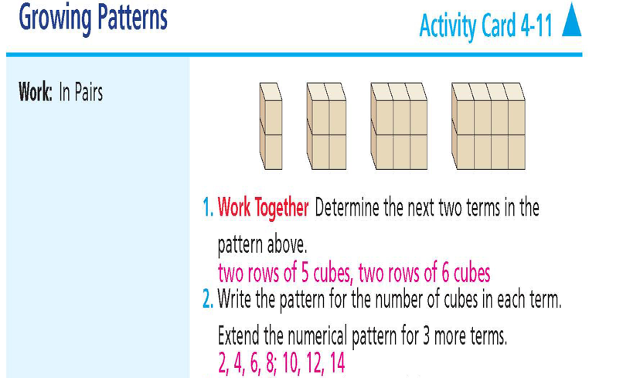

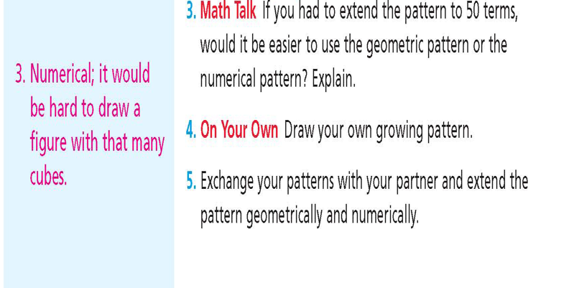

Explore

Whole Group

On the board, display the following growth pattern:



Explain that this pattern is a growing pattern. Each row is growing as are the number of blocks in each row. Can you figure out the characteristics of this pattern and how it’s growing? (It’s growing by one row, and one more block in each row.) To help students, discuss that one way to describe the growth of this pattern is to write the number of rows and the number in each row. This would be the numerical pattern. Have students come to the board to draw what the 6th term will be. Is there a pattern? Can you determine what the 10th term will look like without drawing it out? How do you know?

Small Group

Using the class activity sheet from yesterday, students will work with their same groups from yesterday to examine the growing pattern shown with blocks. Students will use this figure to answer questions 12 and 13 on their class activity sheet.

Next, students will complete activity card 4-11 on Growing Patterns with their group. Students will use small wooden blocks to recreate the pattern shown in the first term (two blocks stacked). They will then recreate the second, third, and fourth term recording the number of blocks in each pattern below their recreation. They will also record the number of blocks in each row and the number of rows. Once the patterns are recreated, students will work together to answer each question on the activity card.

For question 4 on the activity card, students in each group will work together to create a growing pattern using their pattern blocks or small wooden blocks. They will need to have the first three terms displayed. Once all groups are done, groups will walk around to each other’s group trying to describe the growth of each group’s pattern. Results will be discussed in the share.

Share

Here, have students discuss their answers to questions 12 and 13 on the class activity 4-11 sheet (p.156). How did you determine what the pattern was? Did you draw out the geometric pattern or write out a numerical pattern.

Next, groups will share their patterns created using pattern blocks or small wooden blocks. What as the growth pattern for each group? How did you determine what the pattern was? Were there any growth patterns that grew the same but looked different? Were there any growth patterns that you could not determine?

Summarize

Students should have been able to identify, extend, and create growing patterns. Students should also be able to determine a numerical pattern for each pattern created or shown, and be able to describe how it is growing without extending the pattern.

Fuson, Karen C. *Math Expressions. Common Core*. Orlando, FL: Houghton Mifflin Harcourt, 2013. Print.

Day 10- Growing & Repeating Pattern Task Cards

Launch

Using what you’ve learned about extending growing and repeating patterns from the last two days will help you in today’s task. In today’s lesson, students will work in small groups to complete 8 different task cards on extending growing and repeating patterns. After each task card is completed, students will need to come up and exchange their task card for one they have not yet done. Some task cards will ask you to complete a table to record your results, draw or circle a specific term or build a pattern out.

Explore

Each group is given one of the 8 task cards to start. They will need to record their results or answers in their notebook, paying special attention to the card number they have. Students are able to use pattern blocks to recreate a given pattern or have the option of sketching out the pattern shown. Results from each task card will be shared with the whole class once all groups are completed with each task card.

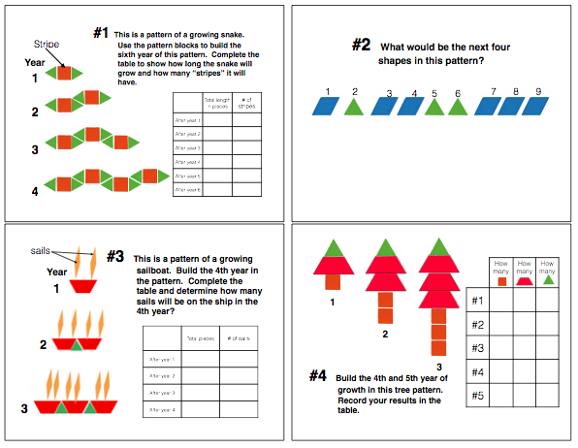

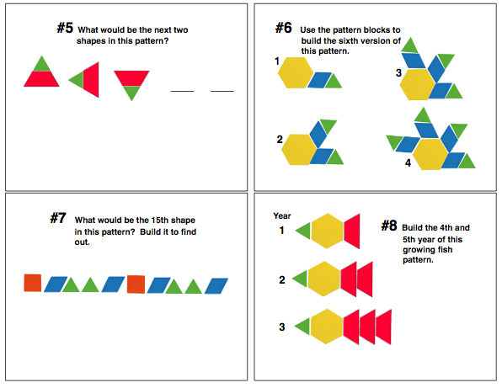

Share

Looking at the results from each task card, were there any patterns that did not grow? Were there any that did not repeat? On task cards 1,3, and 4, you were to record information in the table. What did you notice about the information recorded? Are there any patterns that you can see? Were there any task cards that were difficult to complete?

Summarize

The purpose of this lesson was to give students reinforcement in identifying and extending growing and repeating patterns. Students should also start making the connection that there is a numerical pattern as well.

Pransky, S. (n.d.) Patterns with Shapes Task Cards. Retrieved June 27, 2016 from: [www.teacherspayteachers.com](http://www.teacherspayteachers.com)

Day 11- Growing & Repeating Pattern Task Cards continued…

Launch

Today’s lesson is a continuation of yesterday’s activity using growing and repeating task cards. Students will be given 8 different task cards on extending growing and repeating patterns. After each task card is completed, students will need to come up and exchange their task card for one they have not yet done. Some task cards will ask you again to complete a table to record your results, draw or circle a specific term or build a pattern out.

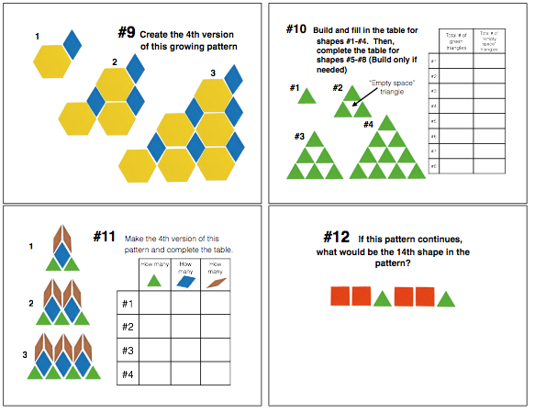

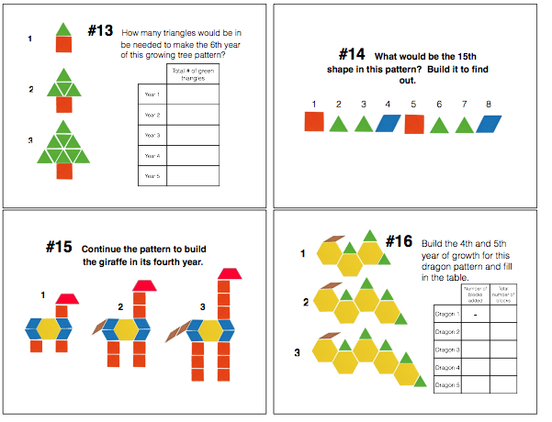

Explore

Like yesterday, each group is given one of the 8 task cards to start. They will need to record their results or answers in their notebook, paying special attention to the card number they have. Students are able to use pattern blocks to recreate a given pattern or have the option of sketching out the pattern shown. Results from each task card will be shared with the whole class once all groups are completed with each task card.

Share

Looking at the results from each task card, were there any patterns that did not grow? Were there any that did not repeat? On task cards 10,11,13 and 16, you were to record information in the table. What did you notice about the information recorded? Are there any patterns that you can see? Were there any task cards that were difficult to complete?

Summarize

The purpose of this lesson was to give students reinforcement in identifying and extending growing and repeating patterns. Students should also make the connection that there is a numerical pattern with some of these patterns.

Pransky, S. (n.d.) Patterns with Shapes Task Cards. Retrieved June 27, 2016 from: [www.teacherspayteachers.com](http://www.teacherspayteachers.com)

Day 12-Numerical Patterns

Launch

In today’s lesson, students will first play a game called Stand up, sit down. Students will also be working in groups to identify and extend numerical patterns. They will be working with Fibonacci sequence to first figure out a pattern. Once a pattern is found, they will extend the pattern out to the 25th term.

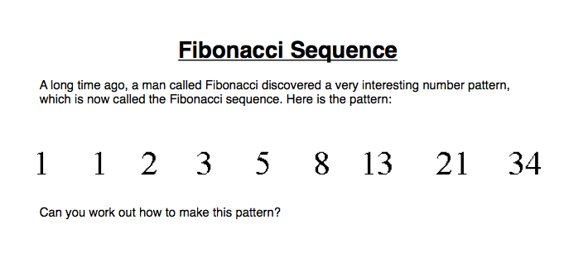

Explore

In the first part of this lesson, students will be playing a game called Stand up, Sit down. In this game, all children stand up and you call out a sequence. Examples would be to do times tables: 5, 10, 15, 20, 25, etc.… As you read off the sequence of numbers, you will purposely miss out one number. When the students think that a number has been missed out, they have to sit down as quickly as possible. The last person standing is out. This is a great game to not only review multiplication facts, but it is also great at getting students started with recognizing a pattern. To make this more challenging, you could count backwards or count by square numbers.

The second activity has students in groups of 4. They will each be given a copy of the Fibonacci sequence. It is a pattern of numbers that students must find a pattern for. Once students are sure they have the pattern, they will show the others in their group. Once all group members agree on the pattern, they will work out the first 25 numbers in the sequence.

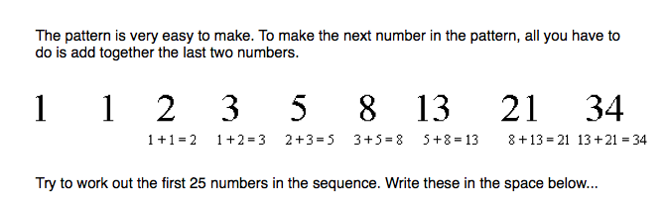

Share

Students will share how they knew when to sit down in the Stand up, sit down game. When did you recognize the pattern? How did you know when one was missed? Are there other ways we could have played this game without numbers?

With the second activity, students share how they found the pattern. Answers should be that they took the last two numbers listed and add them together to get the next number. They repeated this process. What was hard about this activity? Once you found the pattern, could you come up with a shortcut to determine the next term?

Summarize

The point of this lesson was to get students to identify and extend numerical patterns. This lesson also gave students practice in addition, multiplication (and subtraction if you went from large numbers to smaller numbers in the Stand up, sit down game).

Math is Fun, (2014). Fibonacci Sequence. Retrieved June 29, 2016 from: <https://www.mathsisfun.com/numbers/fibonacci-sequence.html>

Day 13- Numerical Patterns Using Tables

Launch

In this lesson, students will continue finding numerical patterns, but recording them and representing them in a table format. Students will first start by playing a game called Number Sequences with a partner. In this game, students will create a two digit number with dice and extend their sequence by their number created starting with a chosen number listed. completing class activity 4-11 (p.155) within a small group.

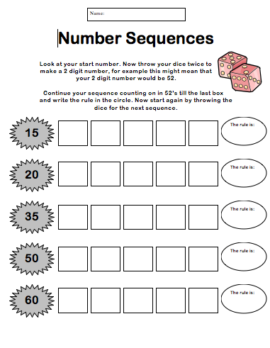

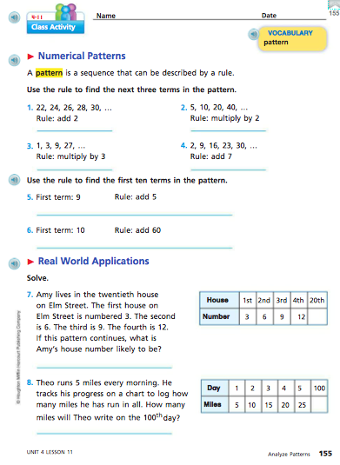

Explore

Given two dice, students will roll them to form a two-digit number. They will start with the chosen number in that row and add their two digit number to that chosen number. They will need to continue this pattern of adding the two digit number they created until there are five terms. They will also need to record their rule.

Once students are done with their game, they will work in small groups to complete the class activity 4-11 (p.155). In this problems 1-6, students are given a set of numbers and a rule, they just need to extend the numerical pattern out. They will be using multiplication and addition in this section. Problems 7 and 8 are a little more challenging because they are word problems with tables to show their data collected. Students will have to work together to find the pattern or rule and answer each question.

Share

During the game Number Sequences, was there anything that you found difficult? Many of your rolled large two digit numbers. If you did not add correctly one time, would that throw off your whole number sequence? How could you double check that your work is correct? Is there a way we could do this using multiplication? Could this work if we used only one die? How about three dice?

With the class activity, I would like students to share their answers for 1-6 by having each group answer one of the questions. For questions 7-8 with the word problems, I would like students to come up and show us how they figured out the answer. For problems 7 and 8, how did you find the 20th or 100th term if they only gave you the first 4 terms? What did you determine the rule to be for this numerical pattern? Is there another rule for this pattern that would work as well and get you the same numbers? Did you have to write out every term until you got to the one you needed to answer the problem?

Summarize

The main idea of this lesson is for students to use a given rule to determine a numerical pattern and also find a rule to extend a given pattern Students created rules using addition and multiplication as well.

Daniels, L., (n.d.) Number Sequences. Retrieved June 28, 2016 from:

<http://www.teachingideas.co.uk/number-patterns/dice-number-sequences-0>

Fuson, Karen C. *Math Expressions. Common Core*. Orlando, FL: Houghton Mifflin Harcourt, 2013. Print.

Humphry, K. (n.d.) Stand Up, Sit Down. Retrieved June 28, 2016 from: <http://www.teachingideas.co.uk/number-patterns/stand-up-sit-down>

Day 14- Pattern Rule Game

Launch

Using what students have done and learned the last two days, students will be playing a game called the Pattern Rule Game. In order to move on the game board and win, students must determine a pattern using a given rule, or determine the rule given the pattern.

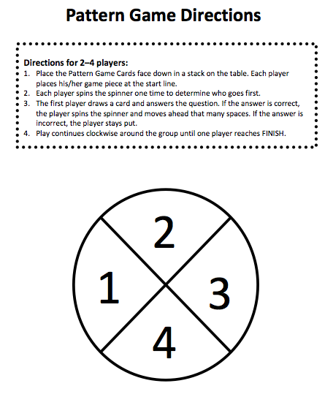

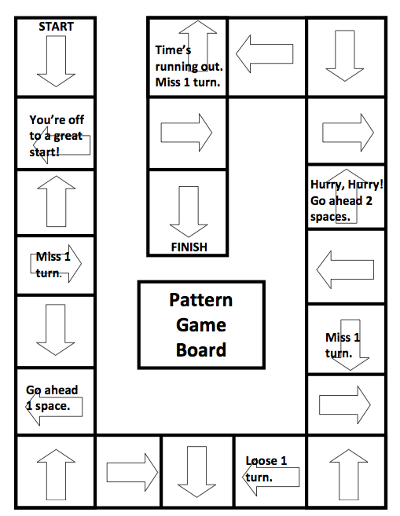

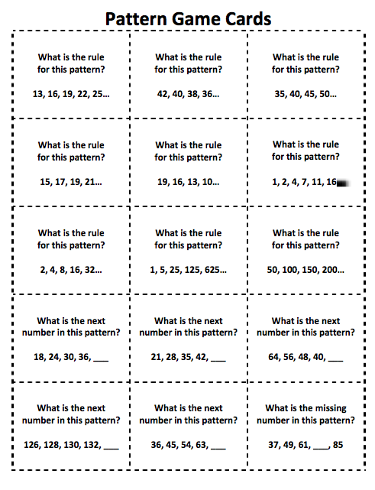

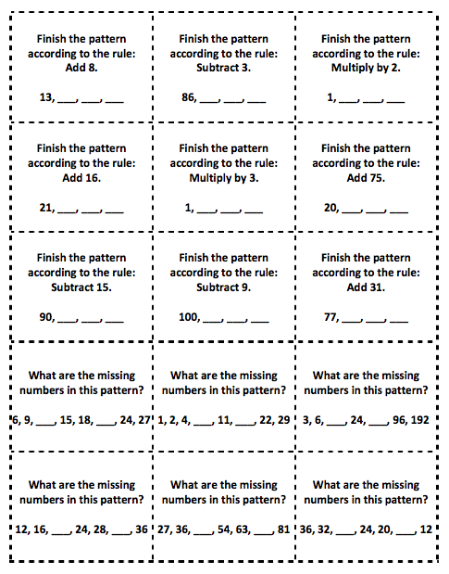

Explore

Students are put into groups of four. The pattern game cards must be shuffled and placed into a stack face down and all player pieces must be placed on the starting line. Each player spins the spinner one time to determine who goes first. The first player draws a card and answers the question. If the answer is correct, the player spins the spinner to determine how many spaces to move. If the player is incorrect, the player stays put until it is their turn again. Play continues until the first person reaches the finish line.

Share

With this game, which card was the easiest to answer: the one where you had to find the rule or the one where you had to extend the pattern? Why? If you could create one more card to add to this deck, what would it be?

Summarize

The main idea of this lesson was to get students to practice finding rules for patterns and following a given rule to extend a pattern.

Virginia Department of Education, (2011) Pattern Rule Game. Retrieved June 28, 2016 from

<http://www.doe.virginia.gov/testing/solsearch/sol/math/3/mess_3-19_1.pdf>

Day 15- Function Tables

Launch

In this last lesson, students will continue practicing using a specific rule to extend a numerical pattern. Using a game called Function Frenzy!, students will have practice with multiplication, division, addition and subtraction. This game addresses state standard 4.2.1.1: Create and use input-output rules involving addition, subtraction, multiplication and division to solve problems in various contexts. Record the inputs and outputs in a chart or table.

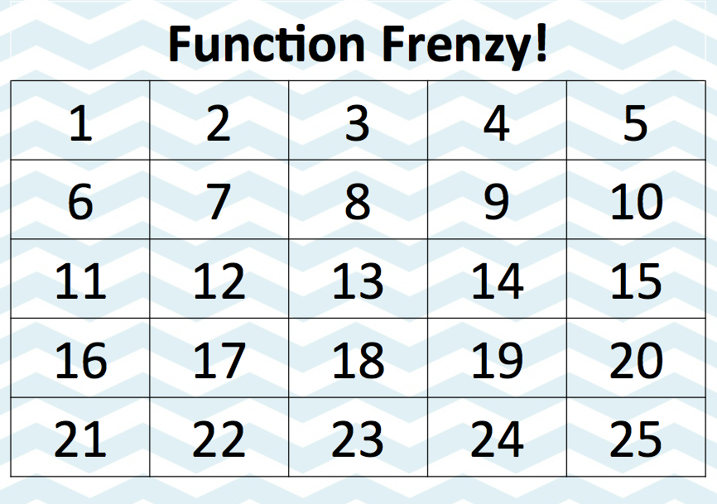

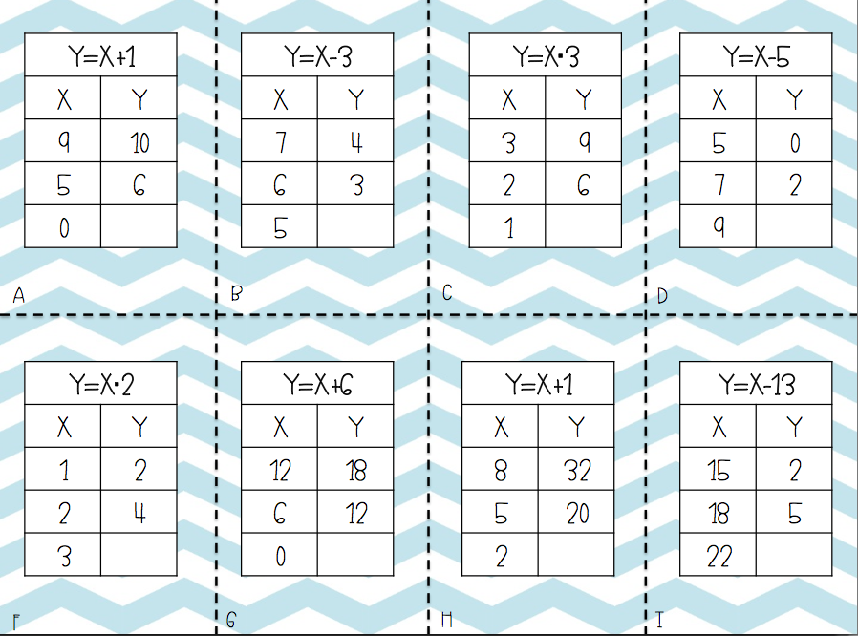

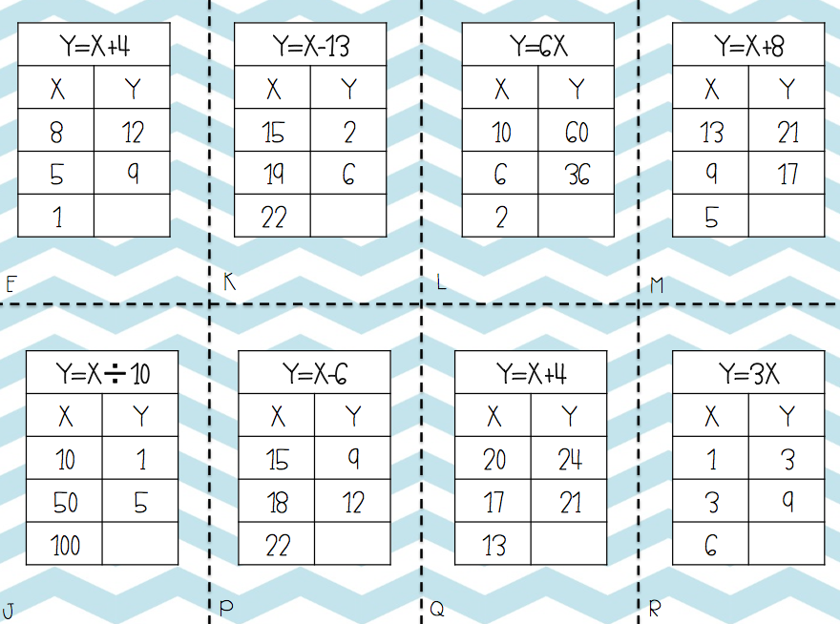

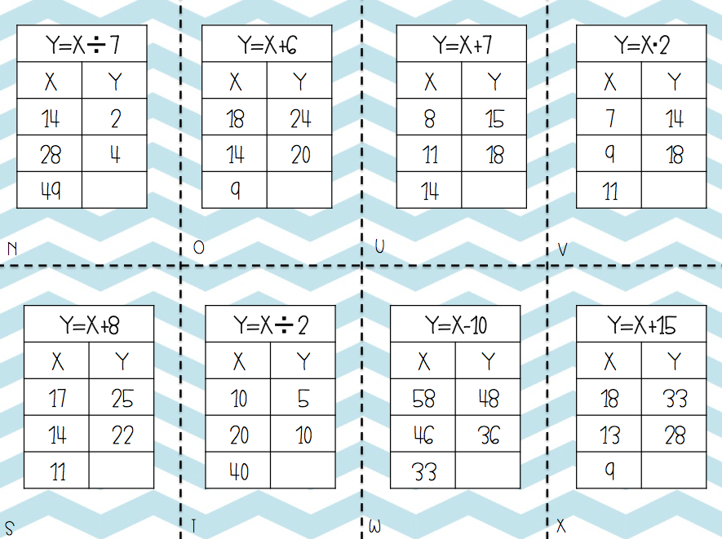

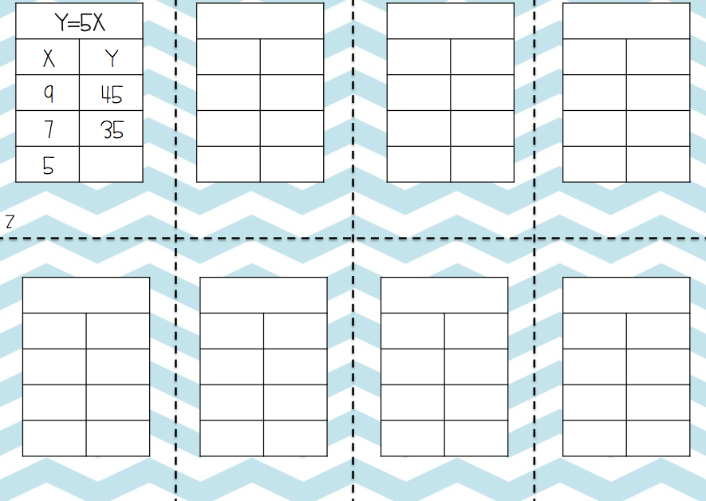

Explore

Students will work in groups of 2 or 4. Students will need to pile up the function table cards face-down on the table. Students will take turns flipping cards over and determining the missing number in the function table. If the answer is correct, mark your place with a chip on the Function Frenzy! Board. If your answer is incorrect, students will not move. The student or team with 4 covered squares in a row (vertically, horizontally, or diagonally) wins. Once students are done, they need to use one of the blank function table cards to create their own card for the game.

Share

When students are done playing the game and there is a winning team or player, talk about the different math they had to do to answer each problem. Students should have determined that they used addition, subtraction, division, and multiplication. Questions about what the rule was should be asked because the rule was given in each function table, it just wasn’t directly stated as the rule. Was there one card in particular or one function that was difficult? I would then ask students to share some of the cards they created for the game and have the class see if they could figure out the answers.

Summarize

Students in this lesson got a lot of practice with their addition, subtraction, multiplication, and division. They also got to use input-output tables and use rules created to determine the missing input or output.

Gentry, S. (2014) Function Frenzy: A Function Table Game. Retrieved on June 28, 2016 from [www.teacherspayteachers.com](http://www.teacherspayteachers.com)

Post-Test





